**Project Design Phase-II**

**Data Flow Diagram & User Stories**

|  |  |
| --- | --- |
| Date | 13 October 2022 |
| Team ID | PNT2022TMID30303 |
| Project Name | Project – Emerging Methods for Early Detection of Forest Fires |
| Maximum Marks | 4 Marks |

**Data Flow Diagrams:**

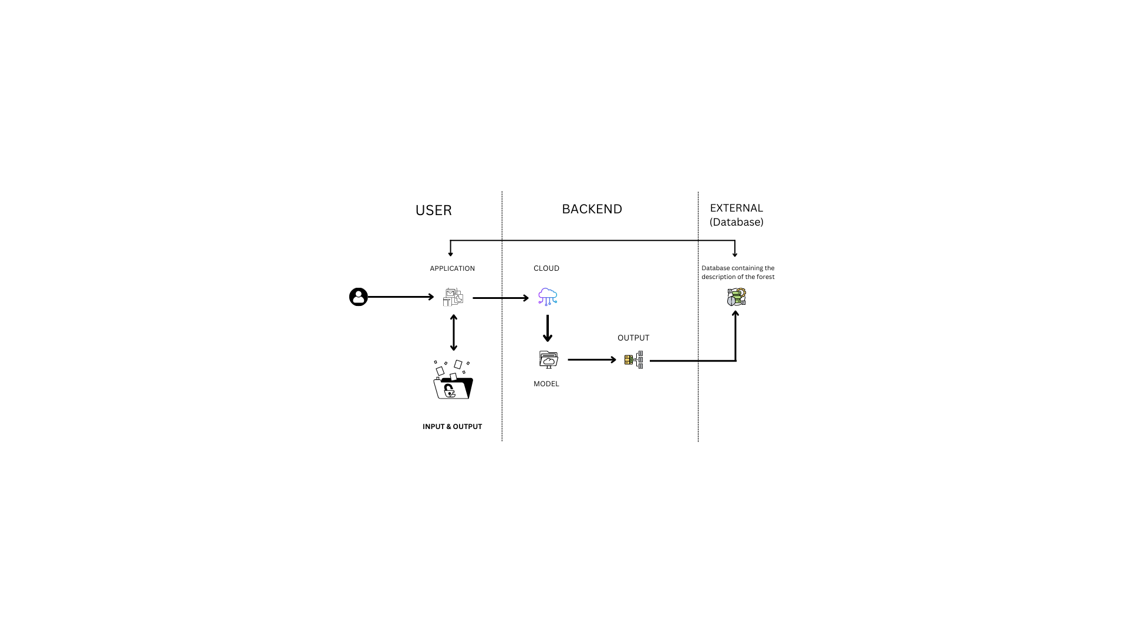

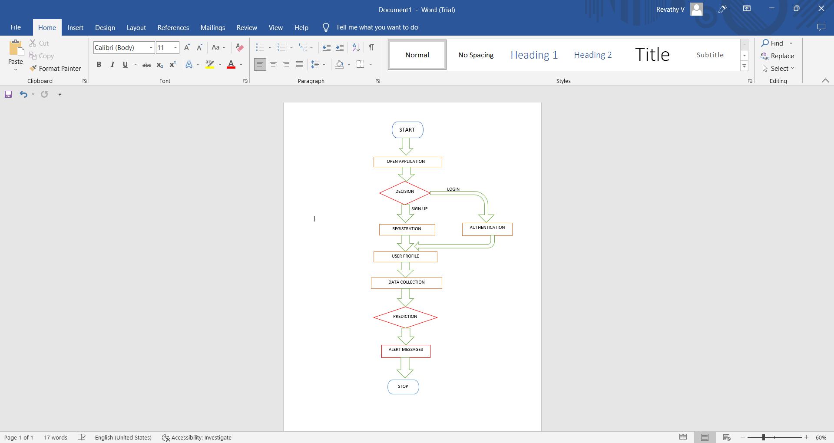

**User Stories**

| **User Type** | **Functional Requirement (Epic)** | **User Story Number** | **User Story / Task** | **Acceptance criteria** | **Priority** | **Release** |
| --- | --- | --- | --- | --- | --- | --- |
| Customer (Forest Officer) | Registration | USN-1 | As a user, I can register for the application by entering my email, password, and confirming my password. | I can access my account / dashboard | High | Sprint-1 |
| Customer (Forest Officer) | Registration | USN-2 | As a user, I will receive confirmation email once I have registered for the application | I can receive confirmation email & click confirm | High | Sprint-1 |
| Customer (Forest Officer) | Registration | USN-3 | As a user, I can register for the application through Facebook | I can register & access the dashboard with Facebook Login | Low | Sprint-2 |
| Customer (Forest Officer) | Registration | USN-4 | As a user, I can register for the application through Gmail | I can directly login through Gmail account | Medium | Sprint-1 |
| Customer (Forest Officer) | Login | USN-5 | As a user, I can log into the application by entering email & password | I can access all the features available in application | High | Sprint-1 |
| Customer Care Executive | Contact | USN-6 | As a customer care executive, I can solve all the login issues and technical issues. | I can contact customer support any time | Medium | Sprint-4 |
| Administrator | Database | USN-7 | As an admin, I can manage database management and server management | I can access data without any delay | High | Sprint-2 |
| Customer  (Forest Officer) | Dashboard | USN-8 | As a userI can get all the details like location and cause of the forest fire | I can find the main reason for the forest fire through the sensors. | High | Sprint-3 |